Inform. Inspire. Involve. Always free. Subscribe
News Science
Arts & Culture Podcasts TV Donate
Teachers' Strategies for Pronouncing and Remembering Students' Names Correctly
By Gail Cornwall Sep 20, 2018
(iStock/HansJoachim)
Sandeep Acharya answered when his teachers and classmates called him Sand-eep, even Sandy, for 12 years before he decided he couldn’t take it any longer: “Junior year of high school, I walked up to the blackboard in every one of my classes and drew a circle with lines radiating from the center. ‘Sun-deep,’ I said in a loud, firm voice. ‘Sun. Like a sun.’ ”
The memory returned to Acharya, CEO of a health care startup, recently when he noticed his 2-year- old daughter introducing herself differently. “To white people, she’d say Savita, with a hard ‘t’ like in ‘torch.’ To everyone else, she’d say her name, Savita, where the ‘t’ makes a soft ‘th’ sound, like in ‘the.’ ”
Rita Kohli, a professor in the Graduate School of Education at UC Riverside, explains the Hindi phenomenon as it applies to her own name: “It’s like Aretha Franklin but without the ‘uh.’ ”
While mispronouncing a student’s name may seem minor, it can have a significant impact on how they see themselves and their cultural background, causing feelings of anxiety, invisibility, shame, resentment and humiliation, all of which can lead to social and educational disengagement. Kohli documented these findings in a 2012 article she co-authored with UCLA professor Daniel Solórzano titled “Teachers, please learn our names!”
Aspirations and motivation can suffer from the cumulative effect of these “mini-disasters,” which also set the tone for how students treat each other. On the other side of the coin, correct pronunciation can help “develop trust and rapport,” according to Christine Yeh, a professor at the University of San Francisco School of Education.
Sponsored
That’s why California’s Santa Clara County Office of Education created the “My Name, My Identity” campaign. The initiative asks community members to take a pledge to pronounce names correctly in order to foster a sense that students of all backgrounds are valuable and belong.
The names of white and nonwhite children alike are mispronounced, Kohli and Solórzano write, but the experience is much more damaging for a child who “goes to school and reads textbooks that do not reference her culture, sees no teachers or administrators that look like her, and perhaps does not hear her home language,” since these cues (plus advertisements, movies and other indicators of societal values at large) already communicate “that who they are and where they come from is not important.” For one Latina study participant, having her name mispronounced made her wish her parents were more Americanized; a Sri Lankan American reported feeling that his name was “an imposition on others.”
They’re not imagining things. Kathryn Campbell-Kibler, a sociolinguist at The Ohio State University, says the effort we put into overcoming a “barrier to communication” depends on (and communicates) social values. “You see the difference if you think about the way Americans typically respond to somebody with a heavy French accent versus somebody with a heavy Mandarin accent,” she explains. When it comes to names, an American who mispronounces the British surname St. Clair (think “Sinclair”), she says, will tend to have a sense of, “Oh, they have a fancy, special language, and if I don’t know how to handle that, it’s a flaw in me.” Whereas a Chinese name might provoke the reaction: “Those names are really hard to understand, and it’s not my responsibility to engage with that.”
The latter also “happens a lot with white teachers responding to names that are seen as typically black,” Campbell-Kibler says. According to Robert Bjork—a psychology professor at UCLA who is a leading scholar on human learning and memory—there are several reasons why names of all cultures can be difficult to remember. For starters, they’re arbitrary labels, as opposed to a nickname like “Red” or “Tiny,” which a person’s physical appearance might trigger. Then there’s the fact that “other demands often occupy our attentional and memory processes when we are meeting somebody new.” Whether that’s at a cocktail party or in a classroom with 33 children, distraction can make it impossible to recall a new name just minutes later. Even when initial storage is successful, Bjork says, retrieval is hampered because we accumulate a huge number of names over our lifetimes, many of which are similar.
On top of these difficulties, there can be linguistic barriers to pronouncing names that aren’t in one’s native tongue, particularly when dealing with differing sound systems. Professor Campbell-Kibler offers up Korean as an example. She says there are two separate sounds that occupy what an English speaker would think of as the “s” space, and a teacher might not have the cognitive capacity to perceive the difference between them.
“If I don’t go and actually learn how to speak Korean extensively for years, I may just always get that wrong,” she says, but this type of real linguistic constraint “doesn’t come up all that often.” In other words, teachers are capable of pronouncing most names correctly.
How then can educators overcome the hurdles to doing so?
It’s tempting to put the first key practice—mustering a legitimate interest in the name—into the bucket labeled “duh” by Samantha Giles, a special education teacher at Hill Elementary School in Garden Grove, California, but it stems from neural complexities. Say you were to ask Professor Bjork how to spell and pronounce his last name. He explains that if he replied “Bee-york” you might ask why it is not pronounced “Bah-Jork,” after which he would tell you that it is a Scandinavian name, similar to the word “fjord” where the “j” is pronounced like a “y.” Or he might add that “Bjork” means “birch,” as in the tree. An exchange like this, he says, “will exercise the very types of processing that enhance memory.” In other words, it overcomes the cocktail party problem. The second essential step, he says, is “to produce—that is, actually say, someone’s name, because retrieving a name makes that name more retrievable in the future than does just hearing it.”
“How would you like me to say your child’s name?” is the specific wording Professor Kohli recommends for parents, and the following for students:
“I don’t know how to say your name yet, can you explain it to me? I’m working on learning it, and it’s important to me to say it the way it’s meant to be said, the way your parents say it.”
Then try the name. Ask if you’re right. Try again, “no matter how long it takes.” Once you’ve got the proper pronunciation, repeat it aloud. Eighth-grade science teacher Carry Hansen, who also coaches cross-country and track as well as coordinating the advisory program for Trinity Valley School in Fort Worth, Texas, recommends using kids’ names as much as possible, almost as obnoxiously as a telemarketer would, until they sink in.
If that whole process sounds awkward, good. Professor Bjork’s research, conducted in partnership with Elizabeth Ligon Bjork, shows that difficulty learning something gives the thing being learned a sense of importance, and errors that trigger elaboration produce better retention. This concept of “desirable difficulties” means the discomfort of admitting you're having trouble pronouncing someone's name could actually aid in recall, and Bjork says “that such a clarifying exchange has a positive effect, not a negative effect, on the person whose name you are having trouble pronouncing.”
Thanks to the power dynamic that makes it hard for a student to question a teacher, the onus of initiating this type of conversation falls on educators, in Kohli’s view, and she says they should take a learner’s approach in doing so. Start with a little soul-searching:
Is this name hard to pronounce, or is that just my vantage point? (Susan Balogh, a teacher at Baker School in Chestnut Hill, Massachusetts, reminds herself, “Unless our names are Lakota, Penobscot or Apache in heritage, they are all ‘foreign.’ ”) Then, be explicit, Kohli says, telling the class “that this is our limitation, not any fault of the student.” Use the “I” statements suggested above and avoid the frustrated looks and embarrassed laughs that tend to accompany pronunciation difficulty. Hansen gives students permission to correct her; in fact, she advises, “tell the kid that they MUST correct you if you are saying their name incorrectly.”
Many teachers report playing “the name game” and Professor Yeh, who teaches school counselors with caseloads of 200-500 students, takes a similar approach, asking each of her graduate students to share the story of their chosen name and its proper pronunciation on the first day of class. Then she, too, gets frank about it, declaring that “we won’t consistently mispronounce a name because we are too afraid to ask, or too afraid to correct ourselves.”
Yeh draws attention to another tactic that can help with pronunciation: learning the basic rules from a variety of languages, “like an ‘x’ in Chinese is pronounced as an ‘sh’ sound, with the tip of your tongue down, below your lower front teeth.” (Just as “a” in Savita makes the “uh” sound thanks to Hindi origin, and the letter “j” in Spanish makes the sound English speakers attribute to the letter “h.” If this seems like too much to wrap one’s head around, remember the classic example of “ghoti” as an alternative English spelling of “fish,” because “gh” makes the “f” sound in “enough,” “o” makes the “i” sound in “women,” and “ti” makes the “sh” sound in “nation.”) Campbell-Kibler, the linguistics professor, confirms: “You can go find that out. Each language is a system, just like English, but the question is, is somebody willing to do that, and what influences how willing they are to do that?”
Even those who know how to say a name like a native speaker may hesitate for fear of cultural appropriation: “It might be socially a little strange to perfectly produce somebody’s name as if I were saying it in the language,” Campbell-Kibler says. That’s why this diverse group of experts all come back to the same bottom-line recommendation: Ask the student and family which pronunciation they prefer.
It won’t always be the one used at home. It is not uncommon for students to choose an Americanized pronunciation or a new name entirely. “At the end of the day, I have to respect the person standing in front of me,” Campbell-Kibler says, “and if they are saying, ‘Call me Joe,’ OK, I’ll call you Joe.”
Just so long as it isn’t for the expediency of school personnel. Professor Yeh says that in the early 2000s, she was told by students at Lower East Side Preparatory High School that they had been assigned an American name or asked to choose one. When kids “basically said, ‘We want our Chinese names back,’ ” Yeh talked to teachers and administrators and was told they “couldn’t possibly learn 300 Chinese names.” And yet, when the students hosted a brown bag lunch where they offered to teach the proper pronunciation of their names, Yeh says, “almost every single teacher and counselor and staff member showed up.”
In the absence of a similar initiative, teachers report using time-honored tricks to remember name pronunciation, like word association (which addresses Bjork’s arbitrary label problem), writing down each syllable in English phonetics, and rhyming (“Alazaeia = Princess Leia” is one Giles uses), as well as new-fangled ones like name pronunciation websites (e.g., www.pronouncenames.com).
What if you witness a mispronunciation by another adult?
Kohli says a classmate of her daughter benefited from a Latina kindergarten teacher who referred to him as his parents did. His first-grade teacher, however, changed both the sounds and inflection. (Professor Yeh reminds, “With many of the names that have tildes or umlauts or little markings, that is actually really important, too.” When making name tents and folders, she says, remember “it’s not just the spoken word; it’s the written name as well.”) While Kohli encourages parents to be direct in advocating for their own child’s name, she sought balance in her dual role as a professor and parent of a classmate, figuring, “I can’t just go in there and slap down my research.”
Instead, whenever the first-grade teacher was in earshot, she made a point to properly pronounce that student's name. Eventually, it worked.
And that might be the most important lesson Kohli and Solórzano have to offer: “[Since] students will often take the cue of fearing or celebrating difference from the climate set up by teachers, ... educators are in a unique position to shape the perceptions of their students” about themselves and others. In the age of growth mindset and “marvelous mistakes,” teachers, counselors, literacy specialists, social workers, administrators, yard staff, PTA members and any other adult who interacts with children at a school can reframe name pronunciation as an opportunity rather than a challenge.
Balogh, the Boston-area teacher, sums it up: “If I can’t make a consistent, good-faith effort to pronounce a name correctly, the implicit message is that I can’t be bothered.” Those who show that they can take an important step toward making all students feel seen and respected, necessary prerequisites for an engaging social and academic experience.
SEE COMMENTS
Want to stay in touch?
Subscribe to receive weekly updates of MindShift stories every Sunday. You’ll also receive a carefully curated list of content from teacher-trusted sources.
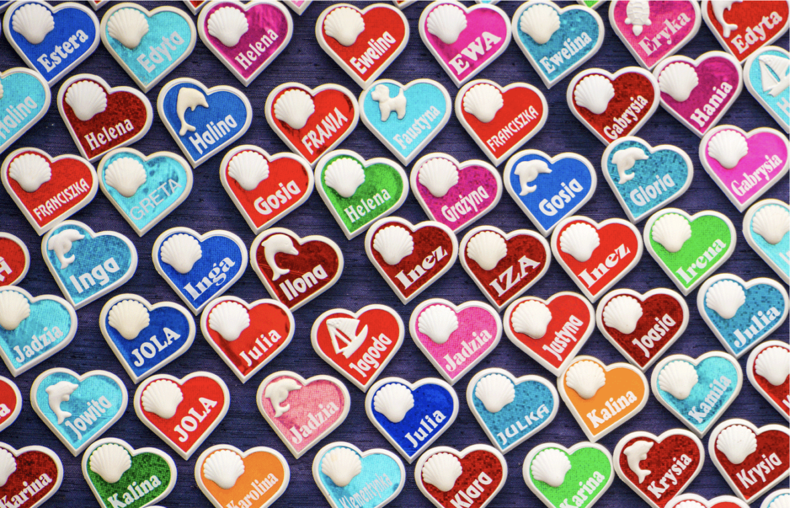
My Name, My Identity | WCSD
Watch later Share
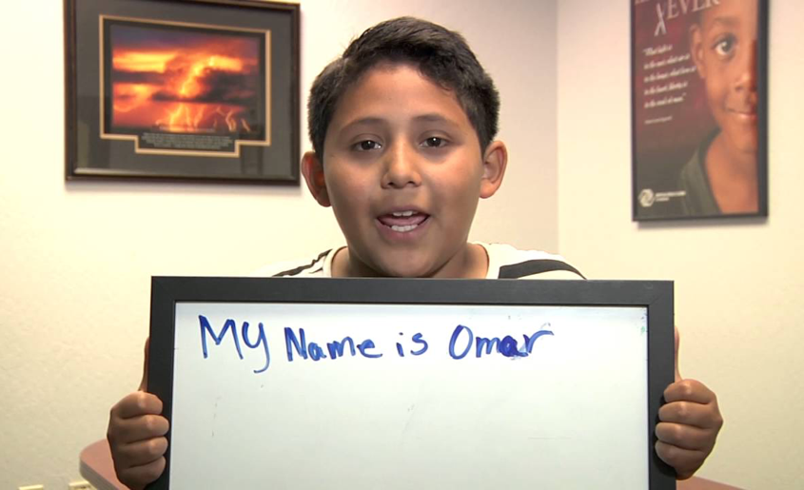
SPONSORED
Copyright © 2020 KQED Inc. All Rights Reserved. Terms of Service Privacy Policy Inside the Reporting Process Contact Us

